DAY 11 – Geerthana - SQL PROJECTS
Project 1: Basic Employee Management System
SELECT * FROM employees;
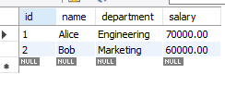
UPDATE employees SET salary = 75000 WHERE name = 'Alice';
SELECT * FROM employees;
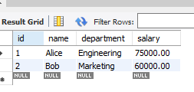
DELETE FROM employees WHERE name = 'Bob';
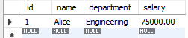

Project 2: Sales Data Querying
SELECT * FROM sales;
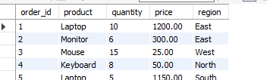
SELECT SUM(quantity * price) AS total_revenue
FROM sales;
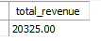
SELECT * FROM sales WHERE region = 'East' AND quantity > 5 ORDER BY price DESC;
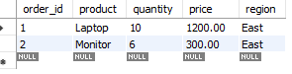

SELECT product, AVG(price) FROM sales GROUP BY product;
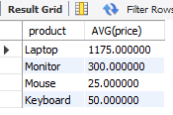
Project 3: Inventory Management
SELECT * FROM products;
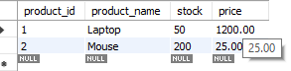
UPDATE products SET stock = stock – 5 WHERE product_id = 1;
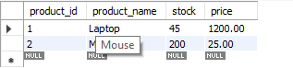

INSERT INTO products (product_id, product_name, stock, price)
VALUES (3, 'Keyboard', 100, 50.00);
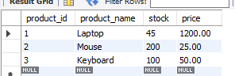
Project 4: Customer Segmentation
SELECT * FROM orders;
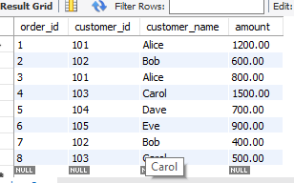

SELECT customer_id, customer_name, SUM(amount) AS total_spending FROM orders
GROUP BY customer_id, customer_name ORDER BY total_spending DESC LIMIT 5;
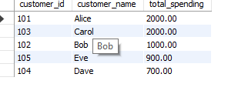

TASK – Day 10
- Youngest employee

SELECT * FROM employee1 WHERE age = (SELECT MIN(age) FROM employee1);
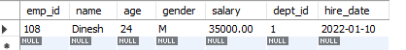

- How many employees are in each department
SELECT d.dept_name, COUNT(*) AS employee_count
FROM employee1 e
INNER JOIN departments d
ON e.dept_id = d.dept_id
GROUP BY d.dept_name
ORDER BY employee_count DESC;

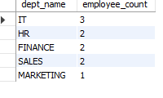
SELECT * FROM employee1 WHERE gender = 'F'AND salary > 45000;
